

Flow chart

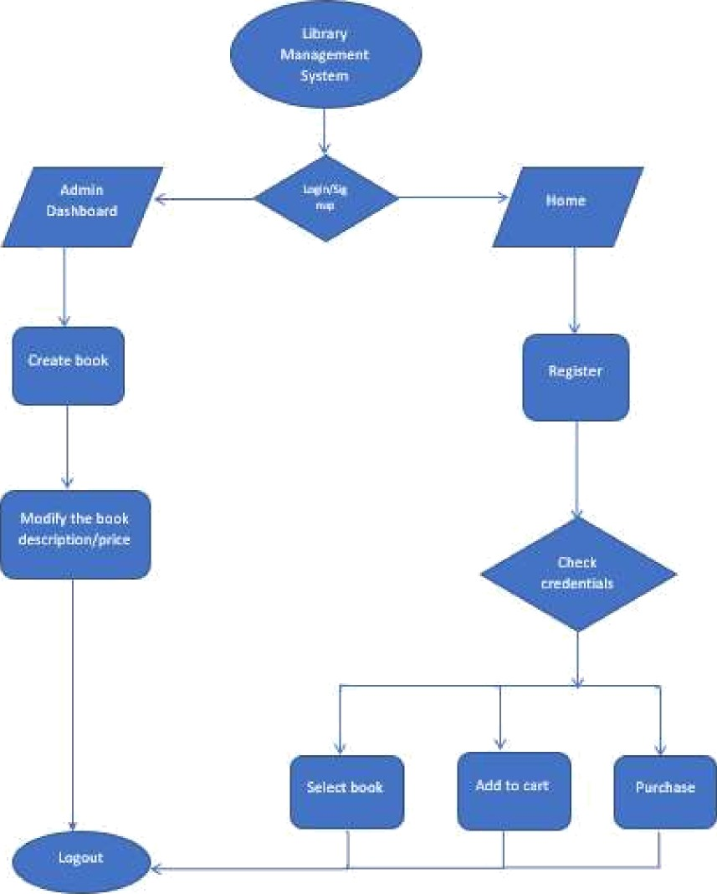

# Use Case

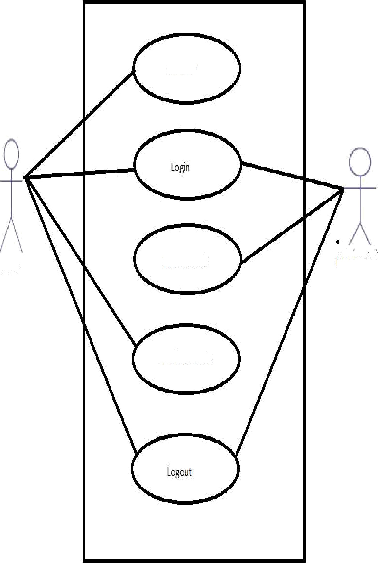

Register

Customer

Create Book

Library Admin

?urcÔa eBooË

## View of Defauìt Page





System

### Sign up page



USERNAME 

PASSWORD 

CONFIRM PASSWORD

SIG NUP

Login Page

# LOGIN

USERNAME 

PASSWORD 

LOGY N

Admin Page

HOMF CREATE BOQK PURCHASE BOOK CART

### ADMIN PAGE